

***National University of Science and Technology (NUST), H-12, Islamabad***

***School of Mechanical and Manufacturing Engineering (SMME)***

***Department of Aerospace Engineering***

**ASSIGNMENT # 01**

**FUNDAMENTALS OF PROGRAMMING**

**CS-109**

**HAREEM FATIMA**

**480429**

**Assignment 1**

**Fundamentals of Programming**

**CS-109**

1. Write a C++ program, take two strings as input from user and check if both strings are equal or not. If they are equal make them unequal by rotating the string.

**Code:**

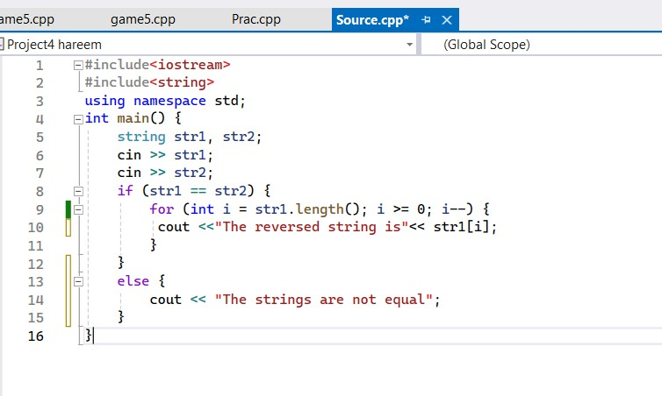

**Output:**

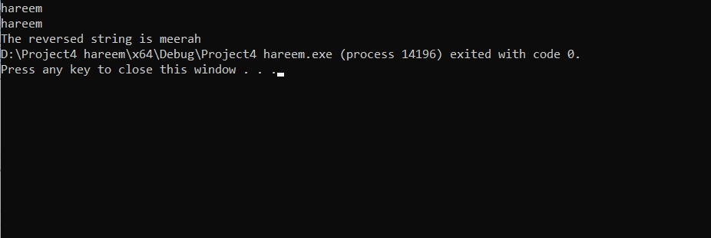

1. Write a C++ program for a string which may contain lowercase and uppercase characters. The task is to remove all duplicate characters from the string and find the resultant string.

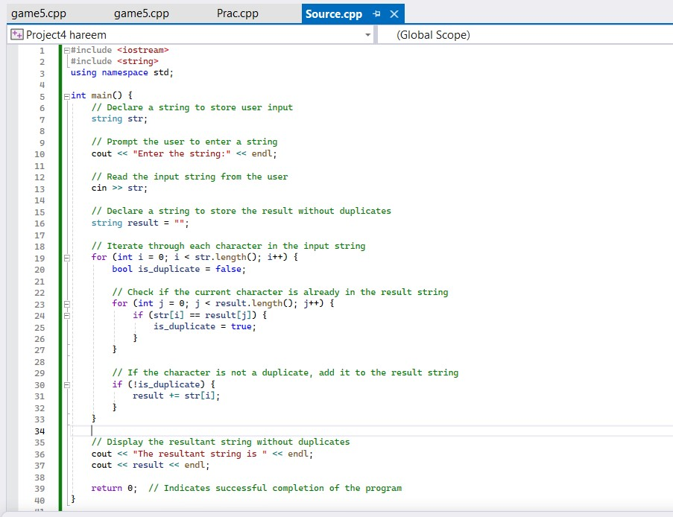**Code:**

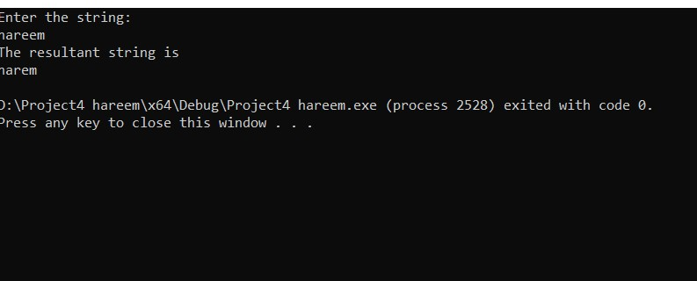**Output:**

3. Suppose an integer array a[5] = {1,2,3,4,5}. Add more elements to it and display them on the screen.

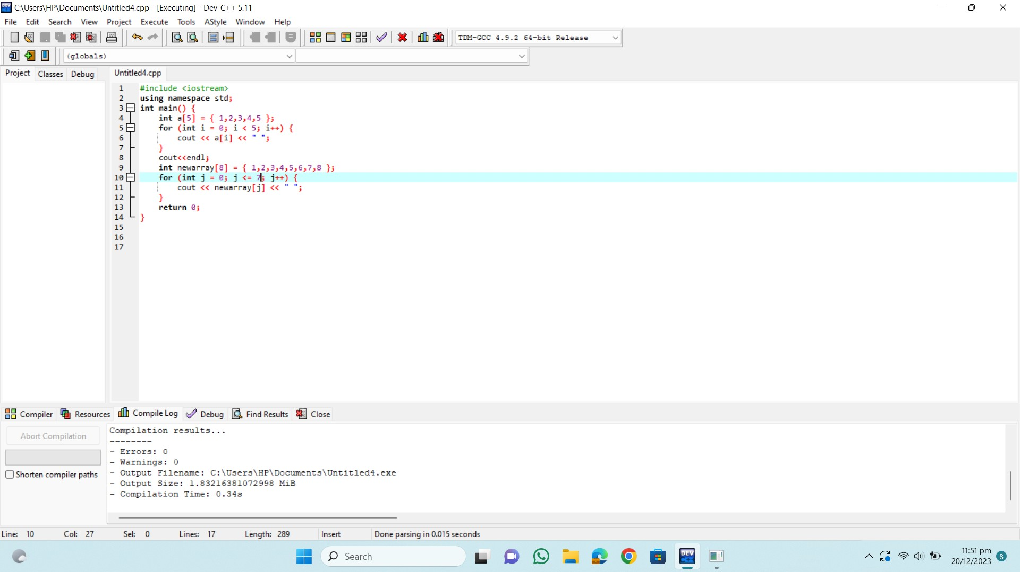**Code:**

**Output:**

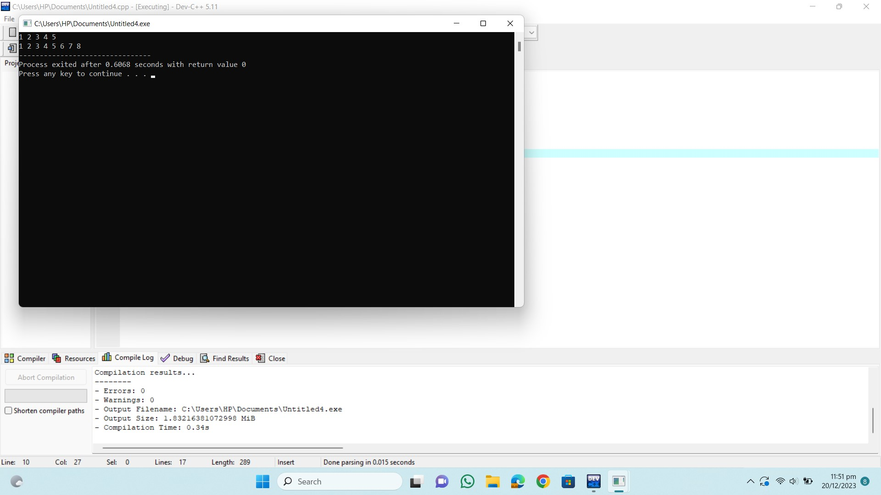

4. Write a C++ program that uses a while loop to find the largest prime number less than a given positive integer N. Your program should take the value of N as input from the user and then find the largest prime number less than or equal to N. You are not allowed to use any library or pre-existing functions to check for prime numbers.

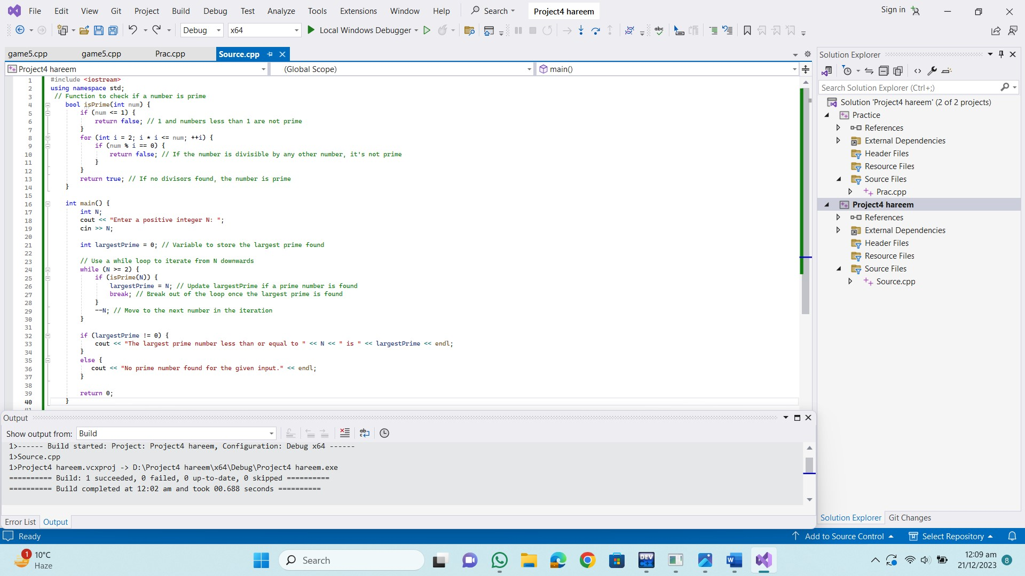**Code:**

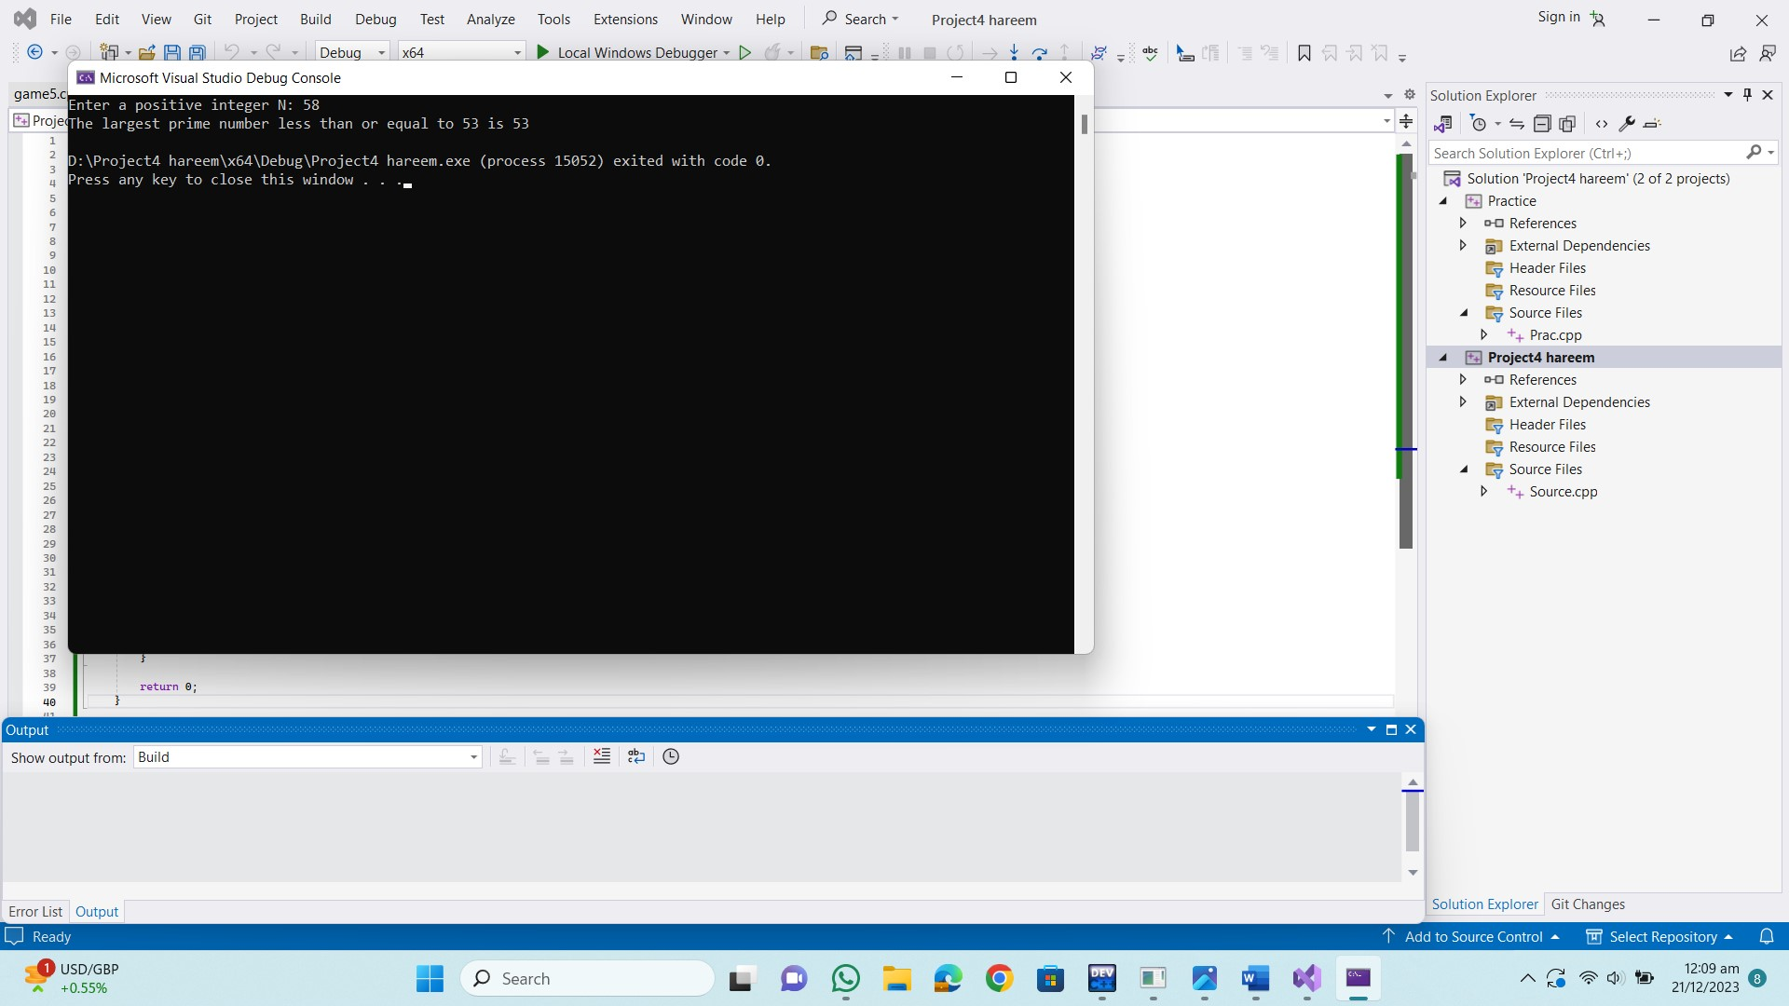**Output:**

5. Implement Bubble Sort on an array of 6 integers.

**Code:**

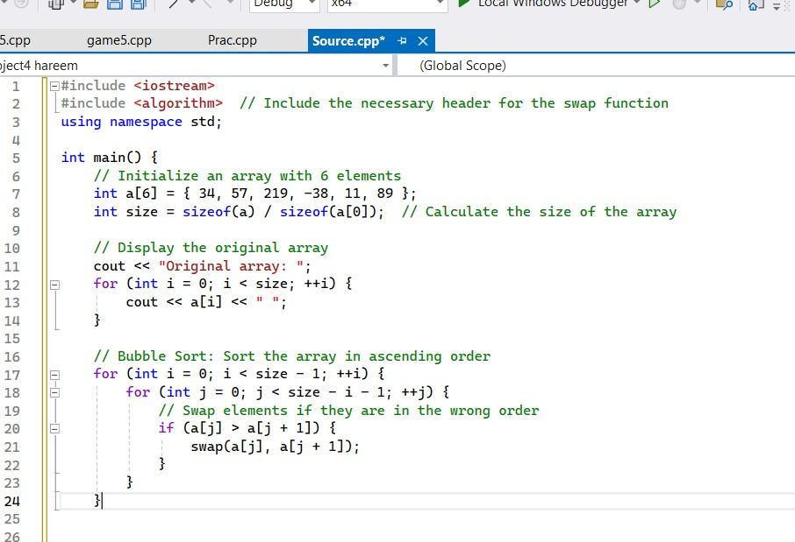

**Solution:**

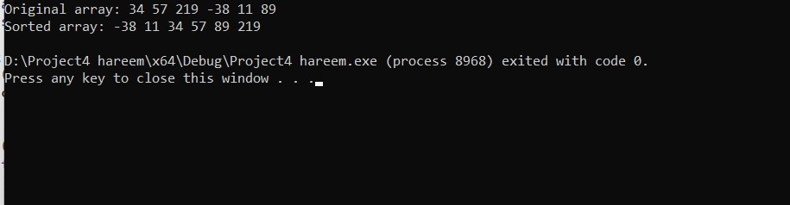

6. Solve any Aerospace/Real Life Problem using C++ Programming.

**Code:**

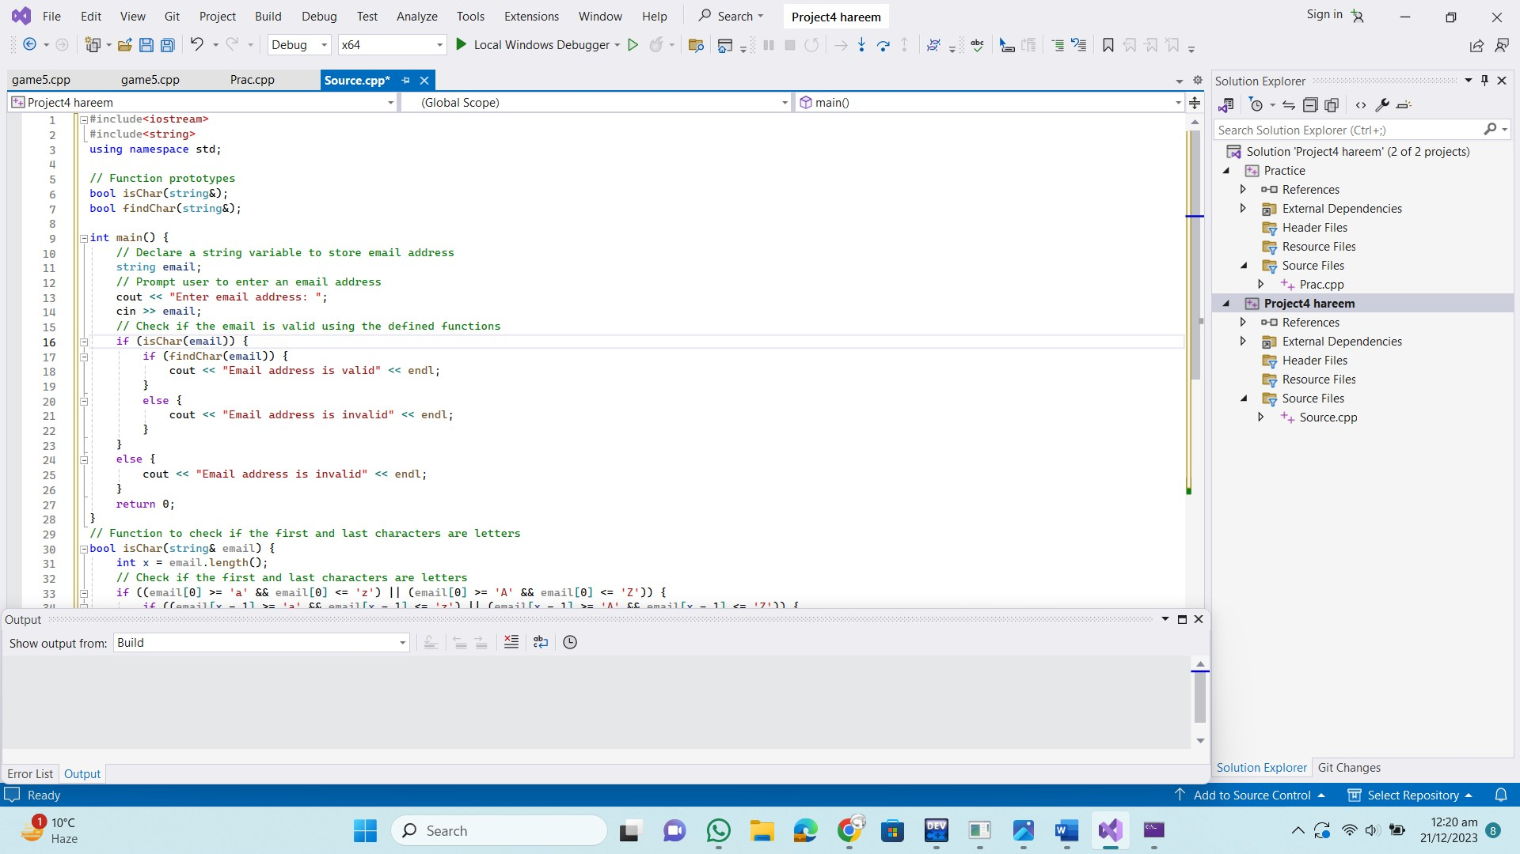

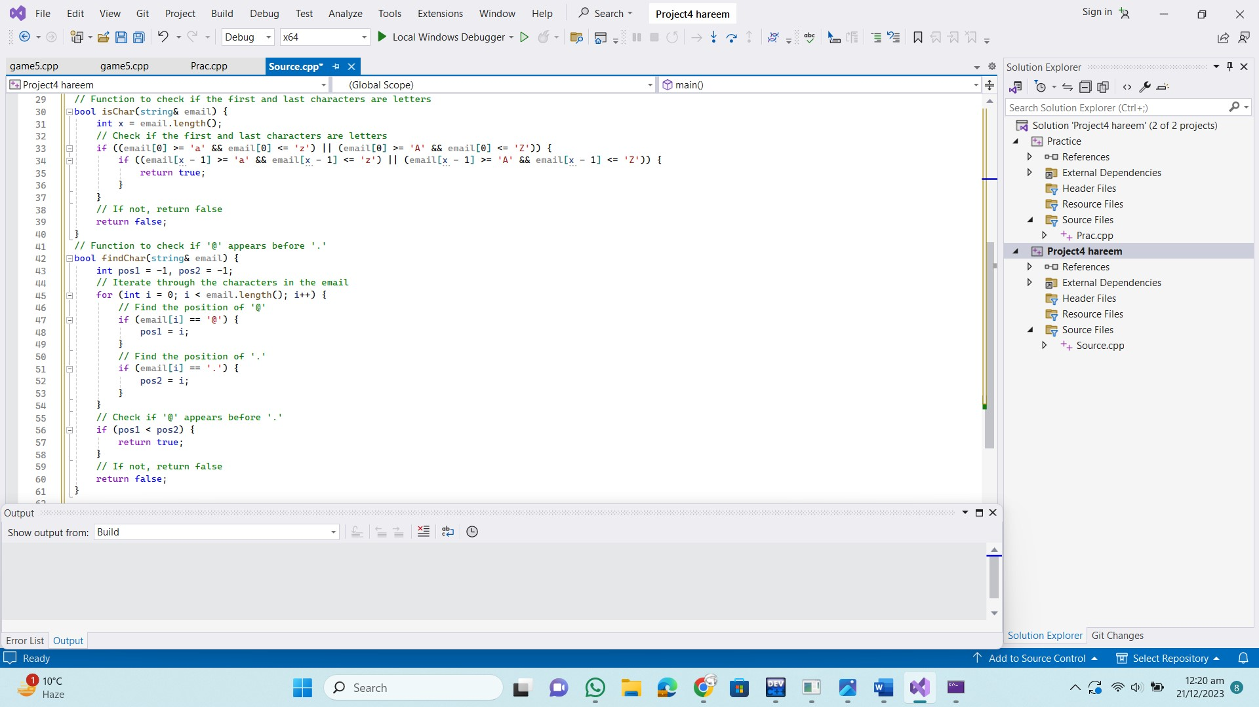

**Output:**

